Name: __________________Per ___
Orthocenter – Circumcenter - Centroid
Worksheet₂
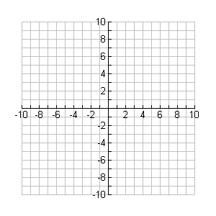
For each problem, graph everything you are doing(use a straight edge). You are expected to be able to find all answers in 1-4 below. If you have difficulty, you may go to my website for step-by-step directions. If I were you, I would first try to do this without the directions.

Given: and
- Find the coordinates of the Orthocenter.
- Find the coordinates of the Circumcenter.
- Find the coordinates of the Centroid.

- Find the equation of the Euler Line. Show which 2 points
you are using. Graph this line on the last graph with the Centroid.

