Name: _____________________ Per ___
Finding Medians, Altitudes, and ⊥ Bisectors
in order to find the Centroid, Orthocenter, and Circumcenter
Worksheet₁

In exercise 1-7, use with coordinates , and .
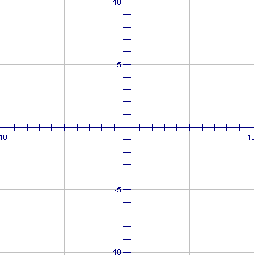
- Plot points R, S, and T.

- Find the equation of the median from R.
  - Find the midpoint of , label it Z.
  - Find the slope of .
  - Find the equation of the median from R.

- Find the equation of the altitude from R.
  - Find the slope of .
  - Find the slope perpendicular to .
  - Find the equation of the altitude from R.

- Find the equation of the perpendicular bisector of .

- Find the coordinates of the centroid of . If you can find the centroid formula, you may use it. Otherwise, you will need to find the equations of two medians and then find their intersection.

Centroid Formula –

- Find the coordinates of the circumcenter (intersection of at least 2 ⊥ bisectors) of .
  - Find the midpoint of .
  - Find the slope of .
  - Find the slope ⊥ to .
  - Find the equation of the ⊥ bisector of .
  - Find the coordinates of the point of intersection of #4 and 6d equations, which is the
coordinate of the circumcenter.

  - Get out your compass and draw in the circle that circumscribes the Δ.

- Find the equation of the Euler line. The Euler line contains the Circumcenter, Centroid, and Orthocenter. Two of these is all you need, of course – and we just found 2 of them.

