Name ____________________________
Period _____

Karel J Robot

Chapter 9 HW

Re-visiting #25 in Chapter 6’s homework – you remember – the fun one about sorting vertical piles of beepers!

This time, let’s do it a different way in order to learn more about:
- delegation (clients and servers)
- parameter passing
- instance variables
- java arrays
- writing clear, easy to follow/modify code

The task is the same so I don’t need to explain that. The difference, however, is that I’m going to explain what needs to be done and in what order (i.e., I’m giving you the algorithm rather than the specifications – new twist). You may NOT use a different algorithm(even if it is better than mine!). By using my algorithm, it is my hope/attempt to force you into certain decisions along the way, thereby learning the above topics. Along the way, you should also look to refactor and/or redesign where methods are placed – each method should be short and contain just a few helper method invocations and/or requests of services of other objects (i.e., object.method() invokations). You should probably begin by trying to write one method - let’s call it sortBeepers() – for the SmarterSorterRobot class. Your challenge is to write in in terms of method invocations of other helper methods (because, of course, you are stepwise-refining the overall, non-trivial task).

Background: there are an unknown number of vertical piles of beepers (no gaps) – each vertical pile has an unknown number of beepers in it (one beeper per corner – no gaps). The bottom beeper of the left-most pile is always at the origin.

I’m intentionally not giving you the algorithm in bullet form (so you can’t just turn the bullets into methods). I’m pretending I’m an end-user (i.e., a quasi-intellect in terms of computer programming – so, I’m going to describe the problem in English).

So, here’s the algorithm:

The SmarterSorterRobot(SSR) does the sorting. She, however, has some helpers (delegates) – the PutterRobot(PUR) and the PickerRobot(PIR). The SSR knows that she always starts off facing East and is standing on the bottom-most beeper in the left-most vertical pile. She begins by walking along the bottom row of all the vertical piles and stopping when she reaches an empty corner. Then, she creates all those PIRs and then, after they are all created, commands each one in turn to pick up all of the beepers in their respective pile(so, for example, if the PIR in the first vertical pile had 5 beepers above him, he would be standing 6 corners above where he was, having picked up 6 beepers). SSR should now querry each PIR for the number of beepers it picked up and she should store those counts as she gets them into a java array of ints. She should then sort that array (see API for Arrays). She should now, working left to right again, create a PUR at the bottom of the first soon-to-be-created pile of beepers – the PUR should know how many beepers it is about to put(the smallest number from the recently sorted array). The PUR should then put all the beepers and go HOME (described below) in the most efficient manner possible. The SSR should now create a second PUR and have it do the same – continue until all piles have been placed (i.e., all piles are now in sorted non-descending order and all the PURs are at HOME position). The SSR should now ask each PIR to go HOME. And, finally, the SSR should now go HOME.

HOME: home is the corner directly North of the top-most beeper in the left-most vertical column.

You will be graded on your design – so, a perfectly working solution with a lousy design will earn a lousy grade. Always be thinking how you can further modularize (refactor) and/or extract out common methods and possibly create a superclass (maintaining the is-A relationship – even if loosly interpreted). If any of your methods have more than about 6 or 7 lines of code, there is probably poor design somewhere.
Snapshots of progression
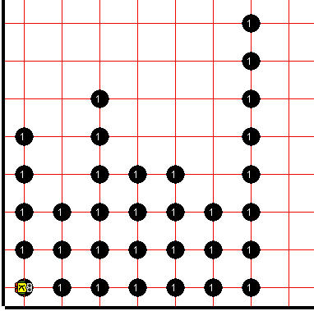
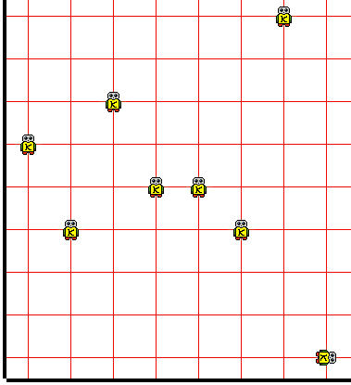
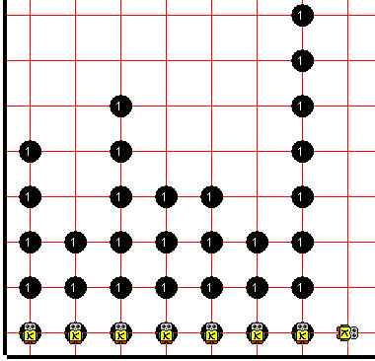
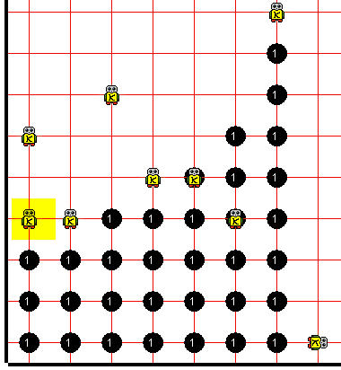
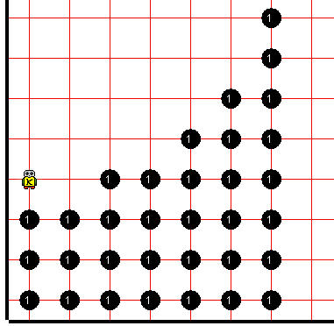
sample starting configuration
all PIRs have been placed
SSR
SSR
all PIRs have picked their beepers
all PURs have placed beepers and they’ve gone home
for this particular set of vertical piles, this is the HOME
all done – everyone is HOME
1
2
3
4
5

