Name ____________________________ Period _____

Karel J Robot - Chapter 7 HW

There is a world file for you called recursion.wld. Please have the 3 classes for these 3 problems located in the same BlueJ project folder.

Karpeter Lab

- Karel is carpeting hallways again. The hallways always have the same general shape as below and are always one block wide. To make sure there are no lumps in the carpet, only one beeper can be placed on a corner. There are no beepers in the hallways to begin. Karel has enough beepers to complete the job(passing ‘infinity’ as the parameter will take care of that) and always starts in the same relative location. Karel should finish where she started. Name your class Karpeter. You should have one public method with the heading: public int carpetHallway() {…}

In addition to carpeting the hallway, the Karpeter class should also be able to return a number representing how many beepers were dropped to carpet the hallway. (extra challenge: accomplish this without the use of any instance variables!! doesn’t seem possible, does it?)

some possible starting positions – karel will always start facing down a hallway, as to want to move around in a clock-wise manner

- Program a robot named Karel to pick up a beeper at the west wall and return to the corner on which she started. There may be other beepers in the path(which should be ignored), but it is known that there is a beeper on 1st avenue directly west of Karel’s starting position. Originally, you do not know which way Karel is facing. You must use recursion – no iteration. You may not use instance variables (no counting so you know how far to return – recursion counts for you!).
Name your class WestWallBeeperGetter. Your one public method should be called getBeeper().

- Karel is facing east. In front of her, somewhere along the street she is on, is a line of beepers (one beeper is on each corner, with at least one beeper in the line). The length of the line of beepers is unknown, but there are no gaps in the line. Karel must pick up and move the beepers north a number of streets equal to the number of beepers in the line. For example, if Karel started off at the origin and there are 5 beepers in the line, the beepers must be moved to 6th street. The beepers must be moved directly north. If the first beeper is on 4th avenue, it must be on 4th avenue when the program is finished; karel should not be standing on a beeper when finished. You may not use any instance variables. Name your class BeeperMover – name your one public method moveBeepersNorth().

// client/driver code
BeeperMover angela = new BeeperMover(2, 8, East, 0, Color.red);
angela.moveBeepersNorth();

Here is some sample code that you might put in your moveBeepersNorth method – this might help you design your class:

findStart();
pickAndTranslateSelfToTheNorth();
dropRow(); // when writing dropRow, it might be helpful to write a helper method called putBeepers()

here is the world you’ll use for all three labs

Again, you have one main which will create 3 different types of bots and have them do the 3 labs. Each bot should be a different color.
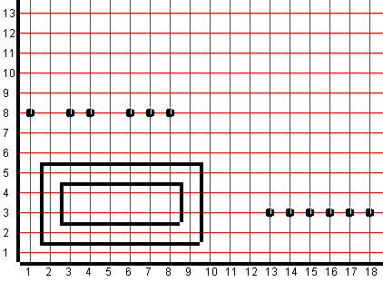
karel might start here facing north(lab 1)
karel might start here facing east (lab 3)
karel might start here facing west (lab 2)

